NAME: Surya Krishna Teja Yandra
REG NO:- 192425065

GITHUB
EXPERIMENT - 14
AIM:
Demonstrate how to work collaboratively in Git/GitHub on a project using the fork-and-pull request workflow.

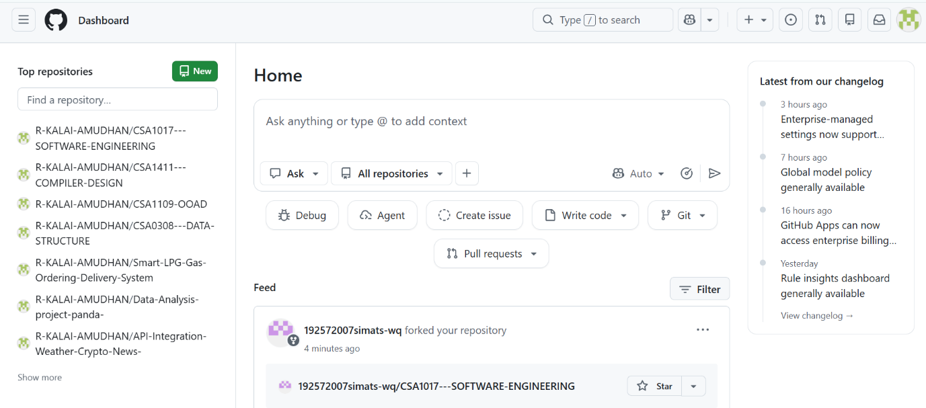
EXPERIMENT – 20
AIM:
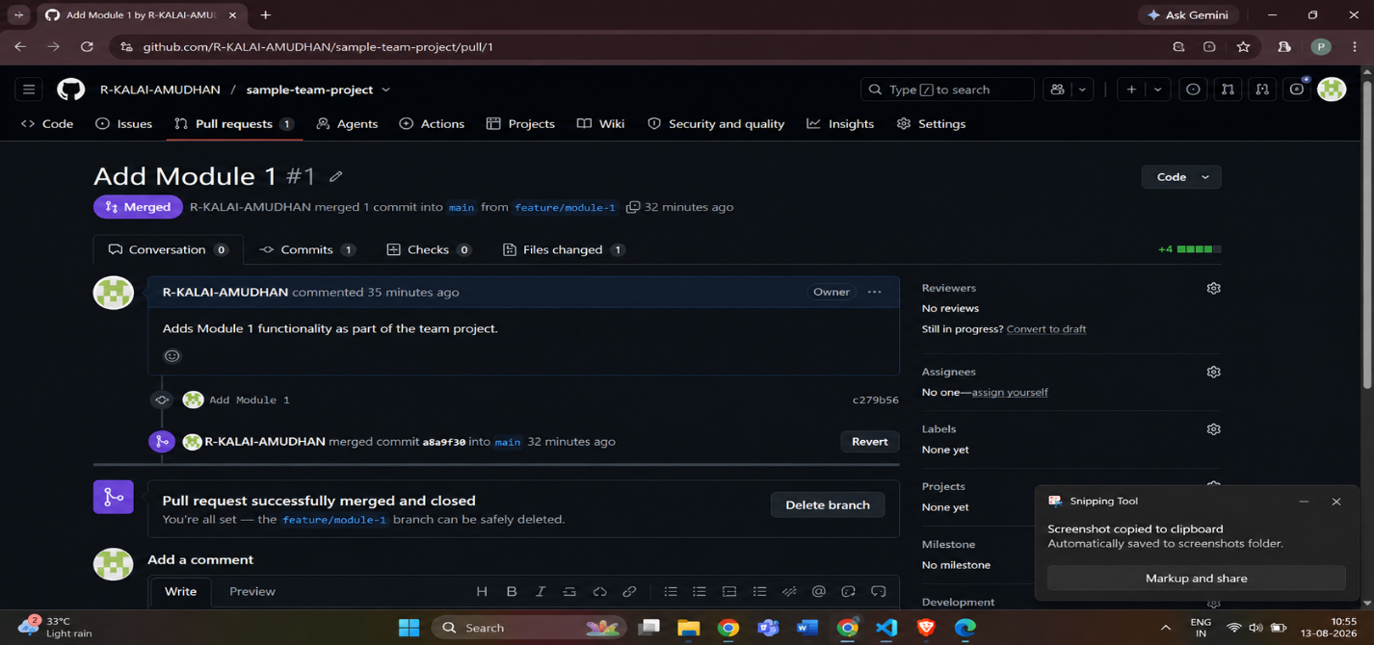
Create a GitHub Repository and Implement Version Control

